Reason Adjunct

✅ What Is a Reason Adjunct?
# Source: AI Source: Provided by: [Data Path: Persons Table -> ID Column: 1, Name_En Column: Motasem Essam] -> From: [Chatgpt (GPT-4-turbo)] on [8/6/2025]
A reason adjunct is a word, phrase, or clause that explains why something happens or why someone does something. It provides non-essential, explanatory background related to the cause or motive of the action.
It answers the question:
- Why?

🔸 Common Forms of Reason Adjuncts:
# Source: AI Source: Provided by: [Data Path: Persons Table -> ID Column: 1, Name_En Column: Motasem Essam] -> From: [Chatgpt (GPT-4-turbo)] on [8/6/2025]
- Conjunctional Phrases/Clauses: because, since, as, due to the fact that
- Prepositional Phrases: because of, due to, owing to
- Adverbial Clauses: because she was late, since I was tired

🔸 Examples of Reason Adjuncts in Sentences:
# Source: AI Source: Provided by: [Data Path: Persons Table -> ID Column: 1, Name_En Column: Motasem Essam] -> From: [Chatgpt (GPT-4-turbo)] on [8/6/2025]
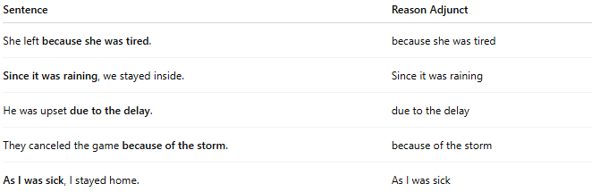
Sentence | Reason Adjunct
She left because she was tired. | because she was tired
Since it was raining, we stayed inside. | Since it was raining
He was upset due to the delay. | due to the delay
They canceled the game because of the storm. | because of the storm
As I was sick, I stayed home. | As I was sick

🔸 Position in the Sentence:
# Source: AI Source: Provided by: [Data Path: Persons Table -> ID Column: 1, Name_En Column: Motasem Essam] -> From: [Chatgpt (GPT-4-turbo)] on [8/6/2025]
- Initial: Because she was sick, she stayed home.
- Final: She stayed home because she was sick.

🔸 Reminder:
# Source: AI Source: Provided by: [Data Path: Persons Table -> ID Column: 1, Name_En Column: Motasem Essam] -> From: [Chatgpt (GPT-4-turbo)] on [8/6/2025]
A reason adjunct is optional — the sentence is grammatically complete without it but lacks the causal detail.
🟢 "They canceled the game."
🟡 "They canceled the game because of the storm." → Reason adjunct adds cause

